Business Requirements Document

of the Website

For

Bazaar Ceramics



Institute of Technology Australia

|  |  |
| --- | --- |
| **Version History** | |
| **Version #** | **Date** | | **Revised By** | **Reason for change** |
| **1.1** | **12/03/2021** | | **Alessandro Ferro** | **NA** |
|  |  | |  |  |
|  |  | |  |  |
|  |  | |  |  |

*Author:* Alessandro Ferro

Contents

1. Introduction 3

1.1. Business Requirements Summmary 3

1.2. Organisation Profile 4

1.3. Scope 5

1.4. Cost Benefits Analysis 6

1.5. Accountability to Sponsor 7

1.6. Assumptions 8

1.7. Constraints 8

1.8. Dependencies 8

2. General Business Requirements 9

2.1. Product Perspective 9

2.2. General Requirements 9

2.3. User Characteristics 9

3. Business Requirements 10

3.1. Requirement 1 10

3.2. Requirement 2 10

3.3. Requirement 3 10

4. Business Process Model 11

4.1. Process Descriptions 11

4.2. Events 13

4.3. Use Case 14

5. Business Data Model 18

5.1. Data Models 18

5.2. Data Descriptions 19

6. Non-Functional Requirements 21

6.1. Accuracy 21

6.2. Audit Trail 21

6.3. Availability 21

6.4. Capacity Limits 21

6.5. Data Retention 21

6.6. Operational Requirements 21

6.7. Performance 22

6.8. Recoverability 23

6.9. Security Requirements 23

6.10. Timing 23

# Introduction

# Business Requirements Summmary

As a producer of ceramic homeware and unique art pieces, Bazaar Ceramics relevance is outgrowing the boundaries of its local market.

The client’s presence in the Adelaide area has been consolidated over several years of activity, but the positive results of their efforts in increasing their reach, caused them to shift their focus to the opportunities offered by the broader national and international market.

The system currently in place, largely paper based and with minimal automation, has proved to be costly and inadequate to fulfill the promotion, sales and administration needs for this task, leading the client to consider the development of an ecommerce solution .

The purpose of this document is to perform and record an analysis of Bazaar Ceramics’ business requirements, that will contribute in defyining the features and functionalities to be integrated in the web application.

By business requirements is intended those systems, processes and characteristics that are considered necessary from the stakeholders point of view, for the solution to satisfy their expectations.

This includes:

* Catalogue browsing
* Shopping cart
* Payment gateway
* Poduction of reports and sales figures
* CRUD funtionalities for products and customers
* Account management
* System performance
* System infrastructure

The term stakeholders describes every person, aside from the developers, involved with the project and the final product.

The identified stakehodlers are:

* Project owner
* Management
* Administrative staff
* Bazaar Ceramics customers

# Organisation Profile

**Bazaar Ceramics Governance**

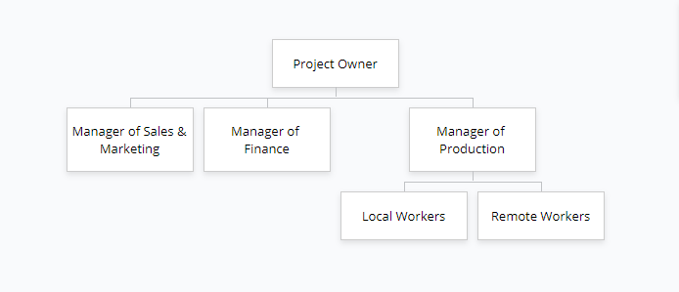

Bazaar Ceramics has a light structure where management directly absolve most of the administrative tasks and customer facing roles.

**Business Owner:** Kym Hayward

**Description:** Decision maker and main stakeholder for the project.

**Remuneration:** Based on profit

**Title:** Gallery director and Manager of Marketing and Sales

**Description:** Reporting to the business owner, is responsible for customer facing and customer care functions, approval of new products design and production of sales figures and reports.

**Remuneration:** Reward based on increase in sales

**Title:** Manager of Finance

**Description:** Reporting to the business owner, is reponsible for products pricing, inventory, investments, customers account authorisation, discounts, monitoring of costs and profits and production of financial reports.

**Remuneration:** Based on Return Of Investment

**Title:** Manager of Production

**Description:** Reporting to the business owner and overseeing the operations of the production workers, is responsible for the order of raw materials, dispatch of items and coordination of the production activities.

**Remuneration:** Rewards based on high productivity and lower production costs.

**Title:** Workers

**Description:** Three local workers and three remote workers reporting to the manager of production. Local workers design and produce products. Remote workers also order raw materials and take care on their own production costs.

**Remuneration:** Base wage with commissions. Local workers higher base wage and lower commission than remote workers.

# Scope

This business requirements specification documents all the relevant information that describe Bazaar Ceramics’ structure, operations and processes, in order to define the system requirements.

The scope of this project is to develop an ecommerce solution, complete with the related documentation and other relevant deliverables.

The system consists of an ecommerce website that provides browsing and purchasing functionalities to Bazaar Ceramics customers and administrative functionalities to Bazaar Ceramics management.

Documentation includes requirements documents and specifications, plans and project maps, design, mockups and prototypes, development and testing documentation and user manuals.

Other deliverables refer to the training provided by the development studio and any other product or service that may be agreed upon during the project’s lifetime.

Roles and Responsibilities

**Developers**

* To produce the system according to the agreed requirements and in observance of the industry standards
* To provide relevant and detailed documentation
* To provide training
* To involve the stakeholders in every phase of the project

**Business owner**

* To participate in every phase of the project and provide honest and current feedback
* To participate in the testing of the product
* To respect the agreed terms and conditions

**Management**

* To participate in every phase of the project and provide honest and current feedback
* To be available for interviews and questionnairres
* To participate in the testing of the product

Deadline

The production ready system, with the documentation and related deliverable will be handed to Bazaar Ceramics by the end of March 2021.

# Cost Benefits Analysis

Costs

|  |  |  |  |  |  |
| --- | --- | --- | --- | --- | --- |
| **Fixed Costs** | **Cost of goods sold** | **Total Costs** | **Sales** | **Total Profit** | **ROI %**  **(Return on Investment)** |
| 1100 | 2560 | 3660 | 4000 | 340 | 0.09 |

Fixed costs include

* Property rent
* Managerial wages
* Non production wages
* Marketing and promotion
* Administration costs

Fixed costs are those expenditures necessary to operate the business without being related to production.

Cost of goods sold include

* Raw material
* Labour
* Factory overhead
* Commissions

Cost of goods sold refers to the expenditures necessary to produce the items sold by Bazaar Ceramics.

The cost to develop the solution is estimated at AU $**2500.00**

Cost of keeping and maintaining the system

|  |  |  |  |
| --- | --- | --- | --- |
| **Domain** | **Hosting** | **SSL Certification** | **Payment Gateway** |
| $20.00/year | $1200.00/year | $20.00/year | 2.9% + $0.30/transaction |

Benefits

The benefits of implementing an ecommerce solution

* Reduced marketing costs
* Reduced administrative costs
* Quicker and more precise inventory management
* Possibility of reducing property rental related costs
* Possibility of reducing managerial wages
* Positive impact on the company image
* Increased reach on remote markets

# Accountability to Sponsor

For the Bazaar Ceramics project, the role of project sponsor is covered by the buisness owner Kym Hayward.

For better chances of successful completion of the project, participation and cooperation is required from both the developer and the project sponsor in every phase of the project life cycle.

To ensure an high degree of flexibility and a stronger involvement from the stakeholders, the project will be developed with an Agile approach.

Requirements phase

* Regular meetings with sponsor to ensure a clear vision of the project
* Sponsor and stakeholders are the primary source of requirements
* Requirements can change at any stage of the development life cycle
* Documentation provided to confirm the requirements

Design phase

* Regular meetings with the sponsor to achieve agreement on the design
* Design is flexible and changes can be implemented at any stage
* Documentation is provided to confirm the design

Development & Testing

* Sponsor directly involved with the testing of the product
* Iterative and incremental process to ensure sponsor’s satisfaction
* Featurs can be added, removed or modified to guarantee maximum adherence to sponsor’s expectations

The Agile approach put a strong focus on customer involvement in the project, adopting an iterative and incremental methodology of development that allows to transition from one phase to another one seamlessly, adapting the project as it evolves.

Considerations

* This methodology relies heavily on sponsor availability
* An higher degree of flexibility risks to overthrow the boundaries of the defined scope
* Being a product oriented approach, where the product keeps evolving and there isn’t a specific end line, Agile can potentially result in higher costs for the completion of the project.

Final statement

The code produced will be written on par with modern industry standards, using current architectural patterns and ensuring that best practicess and processes are followed, such as regular code reviews and testing.

The documentation produced will be complete and thorough and will be written to be understandable also by people without a technical background, anywhere possible.

The product and all the related deliverables will be completed and handed to the sponsor within the agreed deadlines.

# Assumptions

1. The client will provide the data for the database
2. The client will provide any image, picture, logo, or content to appear on the website
3. The scope of the project will not change during the project life cycle
4. The client will guarantee their availability and involvement in the project
5. The customer will provide honest feedback
6. The client will provide the necessary IT infrastructure
7. Sufficient budget has been allocated for the completion of the project

Assumptions assessment table

|  |  |  |
| --- | --- | --- |
| **Assumption ID** | **Probability of occurrence** | **Impact on project if not met** |
| 1 | High | Database created and tested using mock data |
| 2 | High | Website created using placeholders |
| 3 | Medium | Change of project cost and deadlines |
| 4 | Medium | Client not satisfied with final product |
| 5 | High | Client not satisfied with final product |
| 6 | High | Product inoperable by the client |
| 7 | High | Project failure |

# Constraints

* The boundaries of the project’s scope are respected
* The project will be concluded within the end of March 2021
* The project will be concluded within the initial budget set of $2500.00
* The product will comply with Australian policies and legislation
* The quality of the product delivered will be in accordance to the requirements and performance marks agreed upon
* The product will render correctly on all major browsers

# Dependencies

* Project scope has been defined
* Project owner is available and invested in participating in the project
* Agreement on what constitutes the Minimal Viable Product (MVP) is reached
* Content, imagery, logos and data for the database, are available
* The necessary IT infrastructure is available

# General Business Requirements

# Product Perspective

The website is an ecommerce solution with online purchasing and administrative functionalities. Users can log in as either customer or admin, accessing different pages and functionalities.

The customer facing side of the website will display, on different pages, information about the company and the products available for sale and will provide funtionalities to buy products online and to contact the company.

The admin side of the website consists of an admin dashboard that provides functionalities to manage user accounts, inventory and to produce reports.

The customers can register and log in with their account credentials, but the administrators need to be inserted directly in the database.

Customer accounts and admin accounts cannot access each other parts of the website.

# General Requirements

The customers will access the website to

* View information about the company
* Directly contact the company
* Browse the products catalogue
* Search products
* View products details
* Create a personal account
* Add or remove products from the personal shopping cart
* Purchase the products in their shopping cart
* Register
* Log in
* Change password

The admin staff will access the website to

* Create, read, update and delete products from the catalogue
* Create, read, update and delete Customer accounts
* Produce sales reports

# User Characteristics

**Customer:** An individual interested in the products offered by the client, that access the website to browse the company’s catalogue, explore the offers available and possibly purchase products.

A customer access the website without any specific knowledge of its content , structure and functionalities.

Aside from being most likely adults, customers don’t belong to any specific age, economic, political or religious group and should be considered technically unsavvy

**Admin:** An individual that works for the company and has the authority to manage products inventory and customer information. Admins are trained in the usage of the system.

# Business Requirements

# Requirement 1

Visitor

A visitor is an individual that access the website without having an account. Visitors have limited access to the website and its functionalities.

While on the website a visitor can

1. **Register:** Visitor cancreate an account and become registered customers
2. **Navigate:** Visitorcan browse the website pages
3. **Contact company:** Visitor can send a message to Bazaar Ceramics through a form
4. **Select category:** Visitor can select what category of products to see from a dropdown list
5. **Browse catalogue:** Visitor can browse to the catalogue of products sorted by category
6. **Search product:** Visitor can entera product name in a search bar to find that product in the catalogue
7. **View product detail:** Visitor can select a product to view its details

# Requirement 2

Registered Customer

A registered customer is an user that has registered an account on the website. A registered user has access to all the customer facing part of the website and its functionalities.

All the operation performed by the visitor can also be performed by the registered customer.

1. **Log in:** Registered customer can login into their account
2. **Change password:** Registered customer can change the password of their account
3. **Add product to cart:** Registeredcustomer can select a product to add to their personal shopping cart
4. **Manage shopping cart:** Registered customer can add, edit the quantity of, or remove items from their shopping cart
5. **Checkout:** Registered customer can provide their shipping details, and make payment online

# Requirement 3

Admin

An admin is a user that is authorized to manage the products inventory and the registered customers accounts.

Admin cannot register in the system; they can only be added manually.

Admin can access only the admin dashboard of the system.

1. **Manage inventory:** Admin can add, update and remove products from the inventory
2. **Manage accounts:** Admin can add, update and remove registered customers accounts
3. **Request report:** Admin can view sales report produced by the system.

# Business Process Model

# Process Descriptions

Visitor – Contact company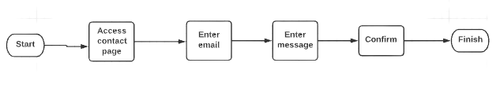

Visitor – Register account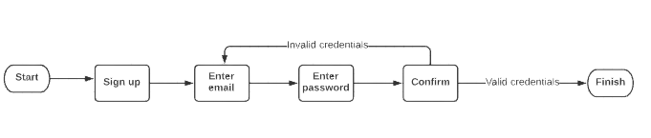

Registered customer - Login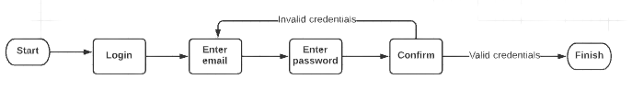

Registered customer – Purchase product

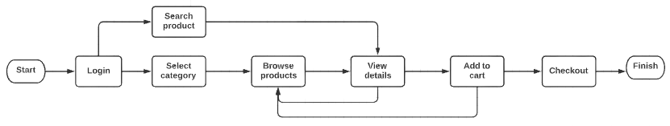

Registered customer – Checkout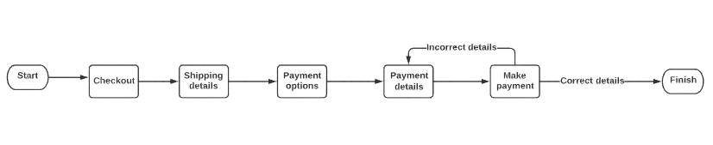

Registered customer – Change password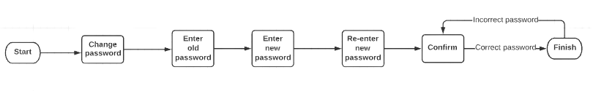

Admin – Add customer account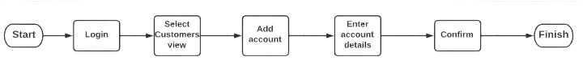

Admin – Manage account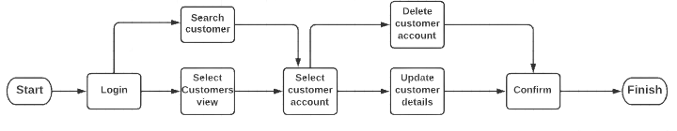

Admin – Add product to inventory

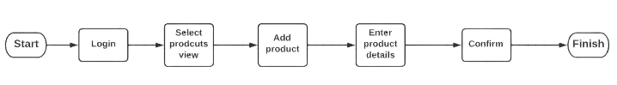

Admin – Manage products in inventory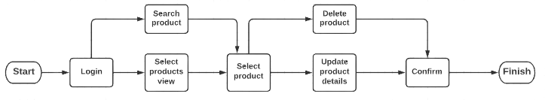

# Events

Visitor related events

* Visitor access the website
* Visitor navigates to a page
* Visitor selects category
* Visitor search product
* Visitor clicks view product details
* Visitor clicks add to cart
* System redirects visitor to sign up page
* Visitor registers account

Registered customer related events

* Customer clicks add to cart
* System creates shopping cart
* System adds product to shopping cart
* Customer clicks checkout
* Customer enters shipping details
* Customer enters payment details
* Customer clicks pay now
* System processes payment
* Customer logs out

Admin related events

* Admin login
* System redirects admin to admin dashboard page
* Admin views customers
* Admin adds new customer
* Admin updates existing customer account
* Admin deletes existing customer account
* Admin views products
* Admin adds new prodcut
* Admin updates existing product details
* Admin deletes existing prodcut
* Admin logs out

General User related events (Include Visitor, Registered Customer and Admin)

* User enter invalid credentials
* System check credentials with records in dataabse
* System validates credentials
* System prompts user to enter valid credentials

# Use Case

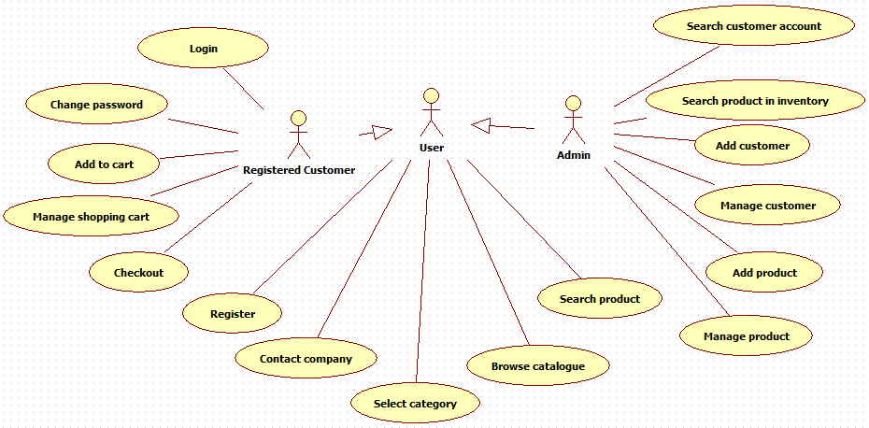

Register

|  |  |
| --- | --- |
| **Use case ID** | 01 |
| **Actor** | User |
| **Description** | A user register a personal account |
| **Preconditions** | The user is not already registered |
| **Normal course** | The user enter email and password in the system and register an account under those credentials |
| **Alternative course** | The email is already in the system.  The system prompts the user to enter the password |

Contact company

|  |  |
| --- | --- |
| **Use case ID** | 02 |
| **Actor** | User |
| **Description** | The user send a message to the company through the contact form |
| **Preconditions** | The user is connected to the internet |
| **Normal course** | The user enter email and message and submit the form |
| **Alternative course** | None |

Select categroy

|  |  |
| --- | --- |
| **Use case ID** | 03 |
| **Actor** | User |
| **Description** | The user select a category of products to browse |
| **Preconditions** | None |
| **Normal course** | The user click category from the navigation menu and select an option from the dropdown menu |
| **Alternative course** | None |

Browse catalogue

|  |  |
| --- | --- |
| **Use case ID** | 04 |
| **Actor** | User |
| **Description** | The user browse through the products of the selected category |
| **Preconditions** | None |
| **Normal course** | The user sees a page with the products belonging to the selected category |
| **Alternative course** | None |

Search product

|  |  |
| --- | --- |
| **Use case ID** | 05 |
| **Actor** | User |
| **Description** | The user enter a product name in the system |
| **Preconditions** | The name of the product is in the system |
| **Normal course** | The user enter a product name and click “search”  The system retrieve the selected product |
| **Alternative course** | The word entered is not in the system. The system notify the user that the product wasn’t found. |

Login

|  |  |
| --- | --- |
| **Use case ID** | 06 |
| **Actor** | Customer |
| **Description** | The customer login into the system using their credentials |
| **Preconditions** | The customer has registered an account in the system |
| **Normal course** | The Customer enter email and password in the system and access their account |
| **Alternative course** | Email or password are incorrect. The ystem propt the customer to enter valid credentials. |

Change password

|  |  |
| --- | --- |
| **Use case ID** | 07 |
| **Actor** | Customer |
| **Description** | The customer change password |
| **Preconditions** | The customer is logged in |
| **Normal course** | The customer enters email, old password, new password and confirm the new password and submit. The system substitute the old password with the new one |
| **Alternative course 1** | The new password is same as the old password. The system prompts the customer to chose a different password. |
| **Alternative course 2** | The new password and the confirm new password fields do not match. The system prompts the user to re-enter the two fields. |

Add to cart

|  |  |
| --- | --- |
| **Use case ID** | 08 |
| **Actor** | Customer |
| **Description** | The customer add a product to their shopping cart |
| **Preconditions** | The customer is logged in |
| **Normal course** | The customer click “add to cart” and the system add the product in that customer’s shopping cart |
| **Alternative course** | The customer is not logged in. The system redirect the customer to the log in page. |

Manage shopping cart

|  |  |
| --- | --- |
| **Use case ID** | 09 |
| **Actor** | Customer |
| **Description** | The customer update quantity or remove items from the shopping cart |
| **Preconditions** | The shopping cart is not empty |
| **Normal course** | The customer click the quantity modifier or the remove item button in the shopping cart |
| **Alternative course** | None |

Search customer account

|  |  |
| --- | --- |
| **Use case ID** | 10 |
| **Actor** | Admin |
| **Description** | The admin search for a specific customer form the admin dash. |
| **Preconditions** | The customer exists |
| **Normal course** | The Admin enters a value in the admin dashboard search bar. The system retrieves the data and display them to the admin |
| **Alternative course** | The cusomter doesn’t exists. The system prompts the admin to enter a valid value. |

Search product in inventory

|  |  |
| --- | --- |
| **Use case ID** | 11 |
| **Actor** | Admin |
| **Description** | The admin search for a specific product form the admin dash. |
| **Preconditions** | The product exists |
| **Normal course** | The Admin enters a value in the admin dashboard search bar. The system retrieves the data and display them to the admin |
| **Alternative course** | The product doesn’t exists. The system prompts the admin to enter a valid value. |

Add customer

|  |  |
| --- | --- |
| **Use case ID** | 12 |
| **Actor** | Admin |
| **Description** | The admin create a new customer in the system |
| **Preconditions** | The customer doesn’t exist |
| **Normal course** | The admin clicks “New customer”, enter the fields required and submit. The system create the new account. |
| **Alternative course** | The customer already exists in the system.  The system prompts the admin to enter a different value. |

Add product

|  |  |
| --- | --- |
| **Use case ID** | 13 |
| **Actor** | Admin |
| **Description** | The admin create a new product in the system |
| **Preconditions** | The product doesn’t exist |
| **Normal course** | The admin clicks “New productr”, enter the fields required and submit. The system create the new product. |
| **Alternative course** | The product already exists in the system.  The system prompts the admin to enter a different value. |

Manage customer

|  |  |
| --- | --- |
| **Use case ID** | 14 |
| **Actor** | Admin |
| **Description** | The admin updates or delete an account |
| **Preconditions** | The customer exists |
| **Normal course** | The admin updates the customer details or delete the account |
| **Alternative course** | None |

Manage product

|  |  |
| --- | --- |
| **Use case ID** | 15 |
| **Actor** | Admin |
| **Description** | The admin updates or delete a product |
| **Preconditions** | The admin updates the products details or removes it |
| **Normal course** | The admin updates the product details or delete it |
| **Alternative course** | None |

# Business Data Model

# Data Models

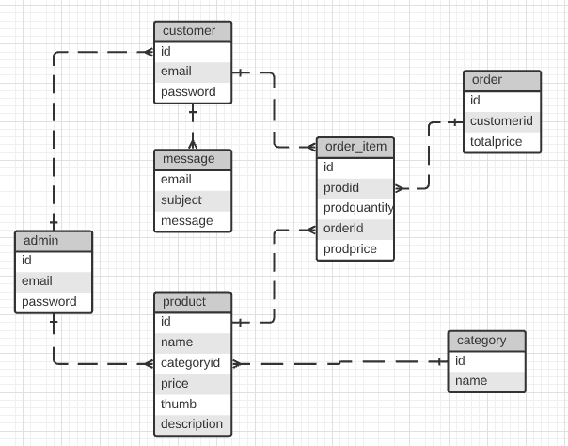

# Data Descriptions

|  |  |  |  |
| --- | --- | --- | --- |
| **Admin** | | | |
| **Data field** | **Description** | **Source** | **Type** |
| Id | Unique identifier | System | Varchar |
| Email | Admin email | Admin | Varchar |
| Password | Admin password | Admin | Varchar |

|  |  |  |  |
| --- | --- | --- | --- |
| **Customer** | | | |
| **Data field** | **Description** | **Source** | **Type** |
| Id | Unique identifier | System | Varchar |
| Email | Customer email | Customer | Varchar |
| Password | Customer password | Customer | Varchar |

|  |  |  |  |
| --- | --- | --- | --- |
| **Message** | | | |
| **Data field** | **Description** | **Source** | **Type** |
| Email | User email | User | Varchar |
| Subject | The subject of the message | User | Varchar |
| Message | The body of the message | User | Varchar |

|  |  |  |  |
| --- | --- | --- | --- |
| **Product** | | | |
| **Data field** | **Description** | **Source** | **Type** |
| Id | Unique identifier of the product | System | Varchar |
| Name | Product’s name | Admin | Varchar |
| CategoryId | Unique identifier of the category the product belongs to | Admin | Varchar |
| Price | Price per unit of product | Admin | Decimal |
| Thumb | Path to the product image | Admin | Varchar |
| Description | Description of the product | Admin | Varchar |

|  |  |  |  |
| --- | --- | --- | --- |
| **Order** | | | |
| **Data field** | **Description** | **Source** | **Type** |
| Id | Unique identifier of the order | System | Varchar |
| CustomerId | Uniquee identifier of the customer who placed the order | System | Varchar |
| TotalPrice | Sum of the price of every item in the order | System | Decimal |

|  |  |  |  |
| --- | --- | --- | --- |
| **Order_Item** | | | |
| **Data field** | **Description** | **Source** | **Type** |
| Id | Unique identifier of the orderitem | System | Varchar |
| ProdId | Unique identifier of the product | System | Varchar |
| ProdQuantity | Quantity of product ontained in the order | User | Integer |
| OrderId | Unique identifier of the order | System | Varchar |
| ProdPrice | Price of each unit of product | Admin | Decimal |

|  |  |  |  |
| --- | --- | --- | --- |
| **Category** | | | |
| **Data field** | **Description** | **Source** | **Type** |
| Id | Unique identifier of the category | Admin | Varchar |
| Name | Name of the category | Admin | Varchar |

# Non-Functional Requirements

# Accuracy

* The system must ensure that every data entered by the user is of the correct type and provided in the expected form.
* The system must ensure that the data it provides to the user or to other systems are correct and in the expected form. This include data manipulated by the system (e.g. calculations).

# Audit Trail

* Record of every transaction handled by the system must be kept and backed up regularly. The infomration recorded must include the customer identifier, the products included in the transaction and their quantities, the price of each item and the total price of the transaction.

Each transaction should also have an id.

# Availability

* Uptimeshould be as close to 99.999% as possible. The strategy adopted from a development perspective is to reduce code maintenance to the minimum by adopting scalabale solutions in every aspect of development, from database design and implementation to software architecture and code.

# Capacity Limits

* The minimum disk space must be of 4GB.

# Data Retention

* All persona and financial information recorded and handled by the system must be protected by authentication and authorization measures, significant security protocols and encryption.

No sensitive data can be stored in the database in plain text.

* The storage and usage of data will comply with the current legislation.

# Operational Requirements

Accessiblity

* The system will respect the accessibility guidelines as defined in the Disability Discrimination Act.
* The content of the website will be screen reader friendly
* Every image, or any other media that will appear on the website, will provide an alternative way to be interpreted by people with visual, hearing or other impairment.

Confidentiality

The website will provide a privacy policy as specified by australian legal requirements for the collection and use of sensitive data.

The policy will detail:

* The types of information collected
* The purpose of the data collected
* Data storage, security and access
* Details of data transfer
* Affiliated websites or organizations
* Use of cookies

Integrity

* Sensitive data will be accessible only by authorized persons
* Authentication and authorization measures will be in place to ensure protection of sensitive data
* The system will handle data only within the purpose of the business operation as specified in the business requirements document

Usability

* The system will be designed to ensure that first time users can easily recognise and accomplish any of the available tasks.
* The user interfce will be minimal and intuitive
* The system will be designed around the tasks the user can perform
* Accessibility guidelines will be respected
* User errors will be highlighted and the appropriate solution will be offered to the user on the same screen when possible (e.g. forms) or on a dedicated error page if not possible.
* The content and labeling of the website will use simple and direct vocabulary
* Elements position and icons usage will reflect modern trends users are familiar with
* Tasks depending on other tasks will adhere to a workflow that will make the operation obvious to the user.

# Performance

* Page load must not exceed 3 seconds
* File optimization – the resources will be organised to reduces the load on the server during each http transaction. A single css file will be used for styling and minimal client side scripting will be included. It will also be taken in consideration the use of css sprites for the use of persistent images such as the company’s logo, backgrounds or any other image the client may wish to include. Products and users images do not fall into this category due to their dynamic nature.
* The system must be able to handle multiple customers concurrently
* The website will be SEO optimized
* The website should render on mobile

# Recoverability

* A backup of the system must be available in a different location
* A full backup of the data will be done daily
* On top of the daily backup, a full backup of the data will be done weekly and the data will be stored in a separate location
* A risk assessment and disaster recovery paln will be implemented and tested

# Security Requirements

* The website will adopt the HTTPS protocol to encrypt the data transferred
* The website wil obtain an SSL certificate
* Server logs will be monitored regularly for suspicious activities
* Data validation will be implemented both on the client side and on the server side
* Enccryption n the server side will implement reliable and secure algorithms
* Session management must include inactivity timeouts, durations, actions and traceability
* Data need to be backed up regularly (consider cloud option)

# Timing

|  |  |  |  |
| --- | --- | --- | --- |
| **Start Date** | 01/03/2021 | **Finish Date** | 20/03/2021 |
| **Project Duration** | 20 Days | | |